**REACT FRAGMENTS**

**T SREE SOWMYA**

**CSE-=04**

**221910304044**

**2/1/2023**

**REVISION EXAMPLES:**

Create an interface such that “start Couting” initial value =1, after clicking on button it should give value as 11 then, 21,then 31…..

App.js :

import './App.css';

import {useState} from 'react';

// import Gitamhyd from './Gitamhyd';

// import Student from './Student';

import User from './User'

// import React,{Component} from 'react';

// import GitamSowmya from './GitamSowmya';

import React  from 'react';

class App extends React.PureComponent {

   constructor()

   {

      super();

      this.state={

         count:1

      }

   }

   render()

   {

      console.warn("PureComponent4044 : check-rerending")

      return(

         <div className="App">

            <h1> {this.state.count}</h1>

            <button

               onClick={()=>this.setState({count:this.state.count+10})}>

            Start Counting</button>

         </div>

      )

   }

}

export default App;

output:

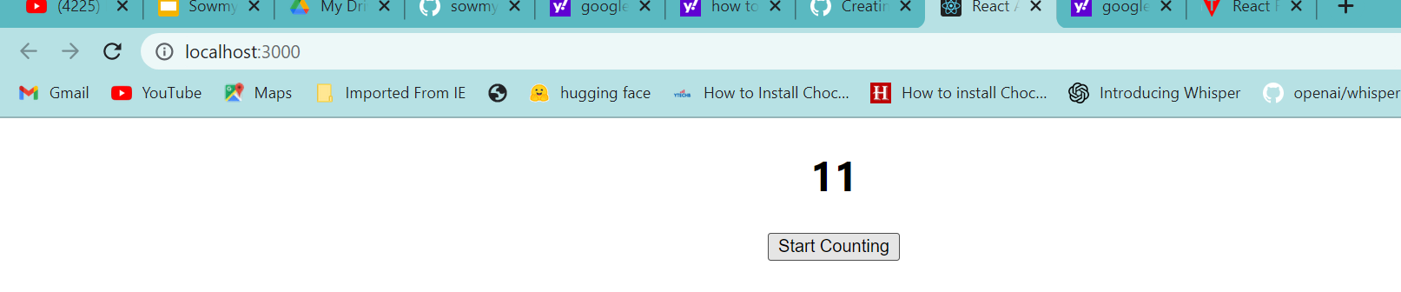

**REACT FRAGMENTS:**

Fragments are called as parts ..<> </> or <fragments> <fragments/>

Whenever we have more than one html tags we use fragments.

Fragments allow you to group a list of children without adding extra nodes to the DOM.

Syntax

1. <React.Fragment>
2. <h2> child1 </h2>
3. <p> child2 </p>
4. .. ..... .... ...
5. </React.Fragment>

## **Fragments Short Syntax**

There is also another shorthand exists for declaring fragments for the above method. It looks like **empty** tag in which we can use of '<>' and '' instead of the '**React.Fragment**'.

**Advantages compared to div tag:**

->Faster execution

🡪less memory

import './App.css';

import React from 'react';

import {useState} from 'react';

// import Gitamhyd from './Gitamhyd';

// import Student from './Student';

import User from './User'

// import React,{Component} from 'react';

// import GitamSowmya from './GitamSowmya';

import { Fragment } from 'react';

class App extends React.Component {

    render() {

     return (

       <React.Fragment>

            <h2> Hello Sowmya -221910304044 ! </h2>

        <p> Welcome to the Gitam . </p>

         </React.Fragment>

     );

    }

}

export default App;

**Output:**

